EXP NO 1: CREATE A SIMPLE CLOUD SOFTWARE APPLICATION AND PROVIDE IT AS A SERVICE USING ANY CLOUD SERVICE PROVIDER TODEMONSTRATE SOFTWARE AS A SERVICE (SAAS).

AIM: To create a simple cloud software application and provide it as a service using any cloud service provider todemonstrate software as a service (saas).

PROCEDURE:

Step1: go to zoho.com
Step 2: login to the zoho.com
Step 3: Create an application and open it.
Step 4: give a name to the application and add a form in the application.
Step 5: Add the required fields and name them.
Step 6:Click done and run the application.

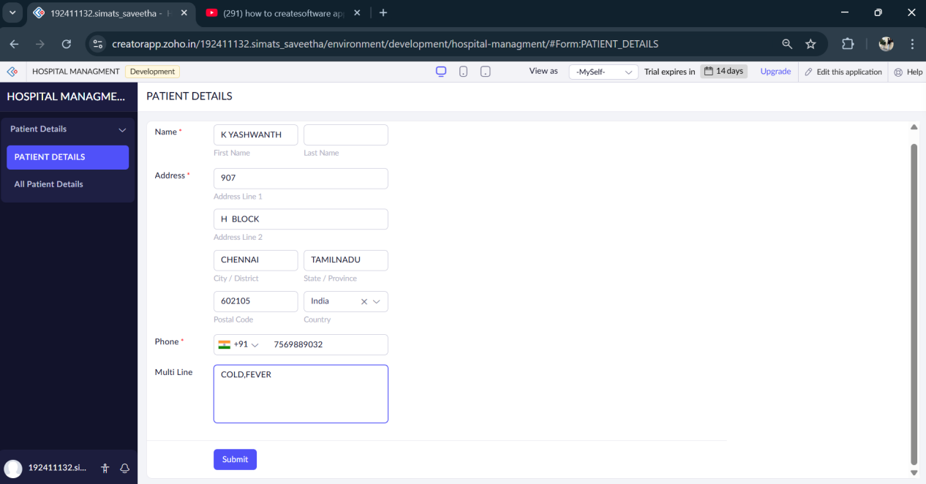
OUTPUT:

RESULT:

We have sucessfully created a simple cloud software to demonstrate software as a service (saas).

